week 2 Day2
Home assignment:
Please complete the following API requests on postman collection

* S07 – Generating Accessibility From DOM (HW)
* S08 – Stop Generating Testcases (HW)
* S14 – Top_p Testcase Generation (HW)
* S17 – DOM to Selenium Code (HW)
* S22 – WebSearch (HW)

🔎 Additionally:
Please check all APIs and verify the payload structure properly.

✅ Modify the payload as per the requirement wherever necessary.
✅ Ensure request body, parameters, and headers are correctly configured.
✅ Test all APIs after modification.

* S07 – Generating Accessibility From DOM (HW)
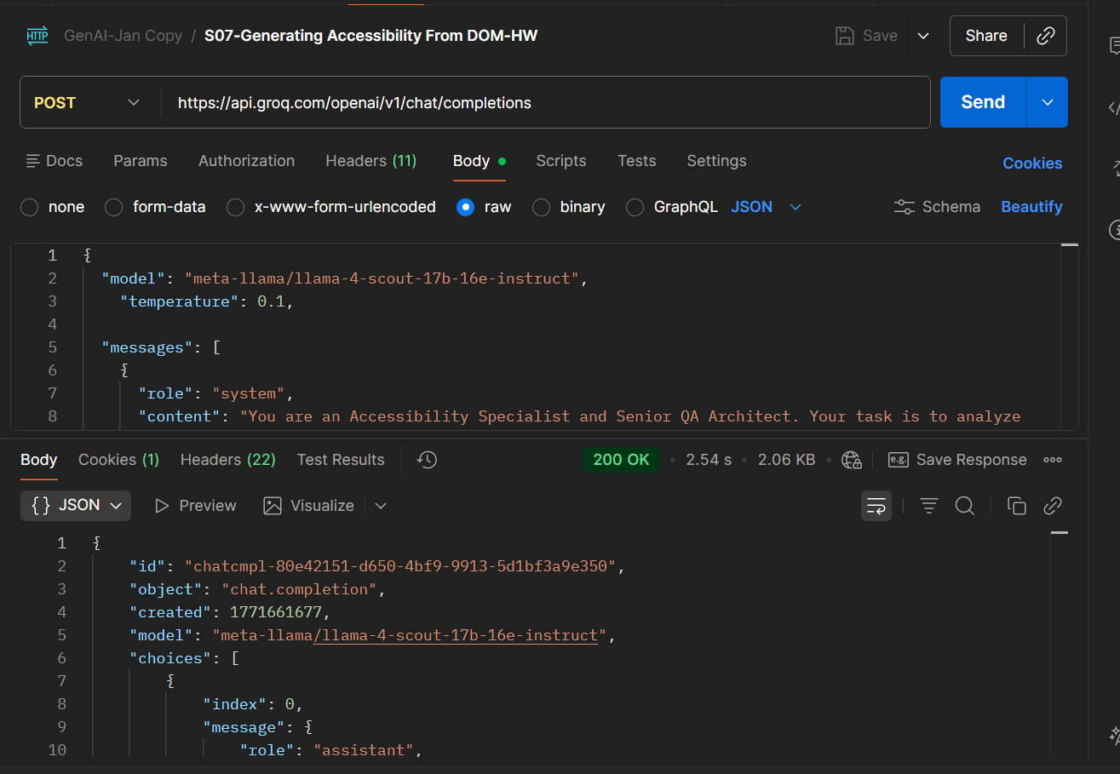
* S08 – Stop Generating Testcases (HW)
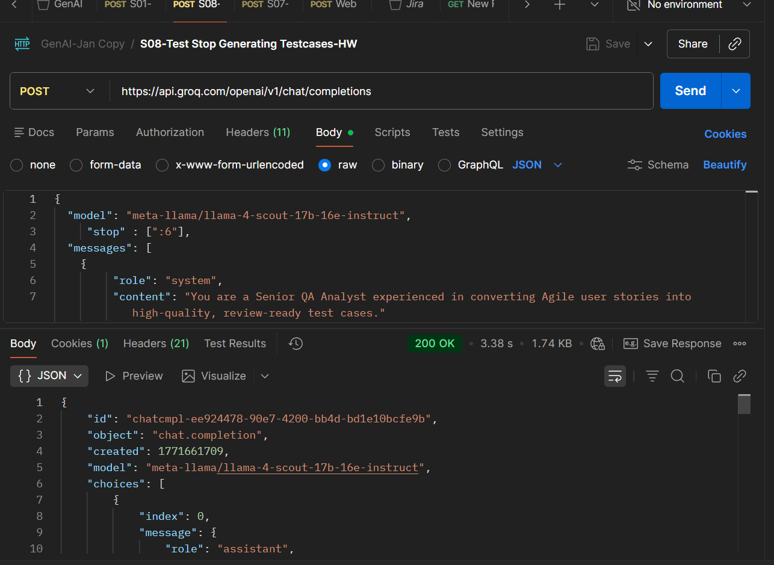
* S14 – Top_p Testcase Generation (HW)
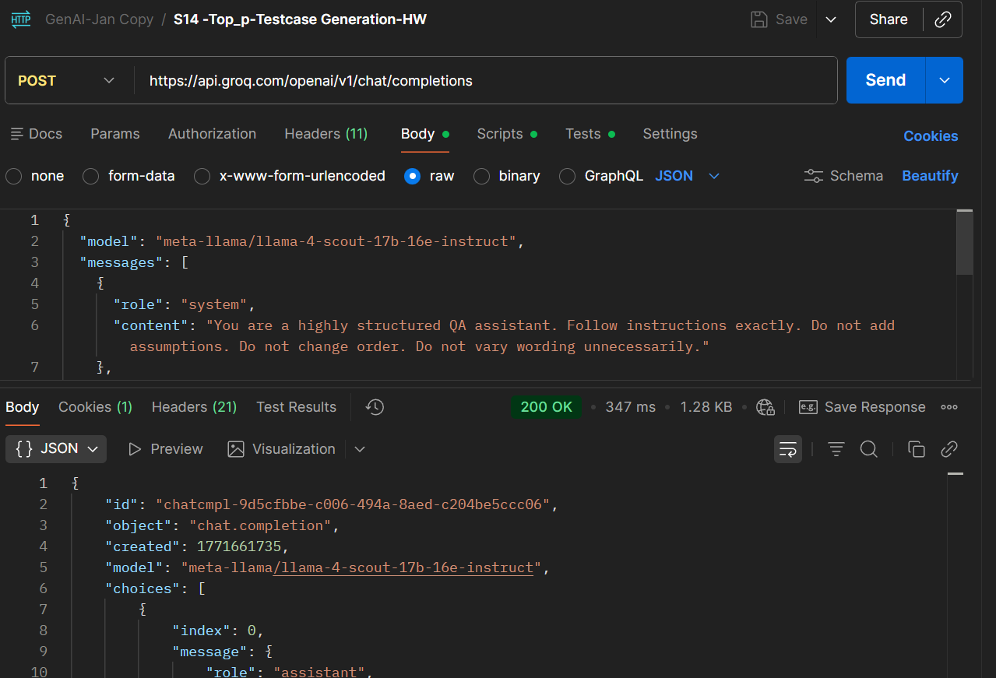
* S17 – DOM to Selenium Code (HW)
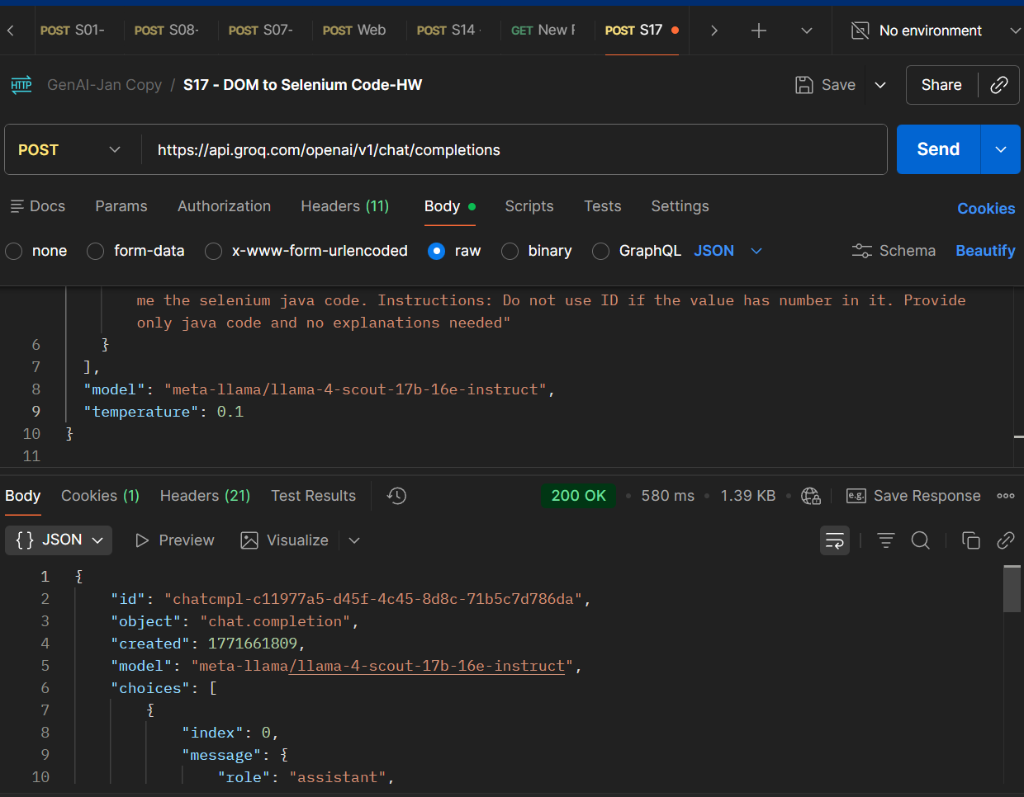
* S22 – WebSearch (HW)
